**Day 1 Lab Assignments**

1. Create the following components, and add them to your root component:
   1. The components' structure should be as the following:
      1. App Component (Root Component)
         1. Header
         2. Products
         3. Footer
   2. Component named header, that will be displayed in page header, which has:
      1. Bootstrap responsive navbar.
         1. Add bootstrap install and link in style.css file
      2. Photo banner
         1. Add it in the assets folder, and then display it under the navbar
   3. Component named footer, and display it in the page footer.
   4. Component named Products to be displayed in the body, make it empty for now.
   5. Add new component (SideMenu) besides the Product component (With any dummy content or image).
   6. The Page layout should be as the following:   
      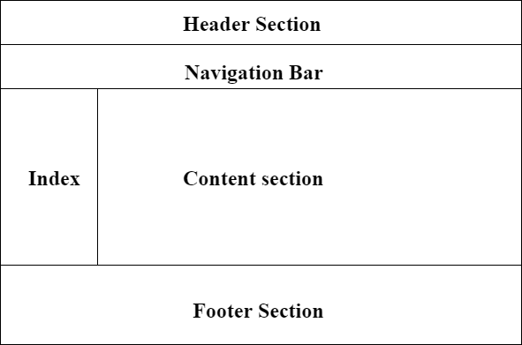
   7. Review the app.module, and see how the components you created were added in imports and in declaration in @ngmodule decorator function.
2. Create New folder in the app folder (Name it: Models), and create the following inside it:
   1. Class Store, has properties:
      1. Name
      2. Array of branches
      3. Logo
   2. Interface named IProduct, which has:
      1. ID – of type number.
      2. Name – of type string
      3. Quantity – Of type number.
      4. Price – of type number.
      5. Img – of type string
      6. CateogryID – of type Number
   3. Interface Named ICategory, which has: ID, Name.
   4. Enum named DiscountOffers with values: (“No Discount”, “10%”, “15%”). **[Bonus]**
3. In the product component:
   1. In the Component class, add the following properties:
      * 1. Property “Discount” of type DiscountOffers Enum. **[Bonus]**
        2. Object of Store class.
        3. Propery “ClientName” of type string.
        4. Object of IProduct interface,and initialize it and add one product.
   2. In the Component HTML:
      * 1. <h1> tag to display store name (Use angular Expression {{}}).
        2. <img> tag to display store logo .
        3. Show all values of interface with any tags.

**<Script>document.write(“Thank YOU”) </Script>**